Updating Personal Information in ILLiad

It’s important to ensure your personal information is up-to-date in ILLiad, as it currently does not get updated with OPUS or other database information. To check or update your personal information, follow these steps.

- First, you'll need to log in to ILLiad. You can do this by going directly to the link: https://illiad.library.emory.edu/logon/ or you can follow the Quick Link for Interlibrary Loan directly from the Pitts homepage.
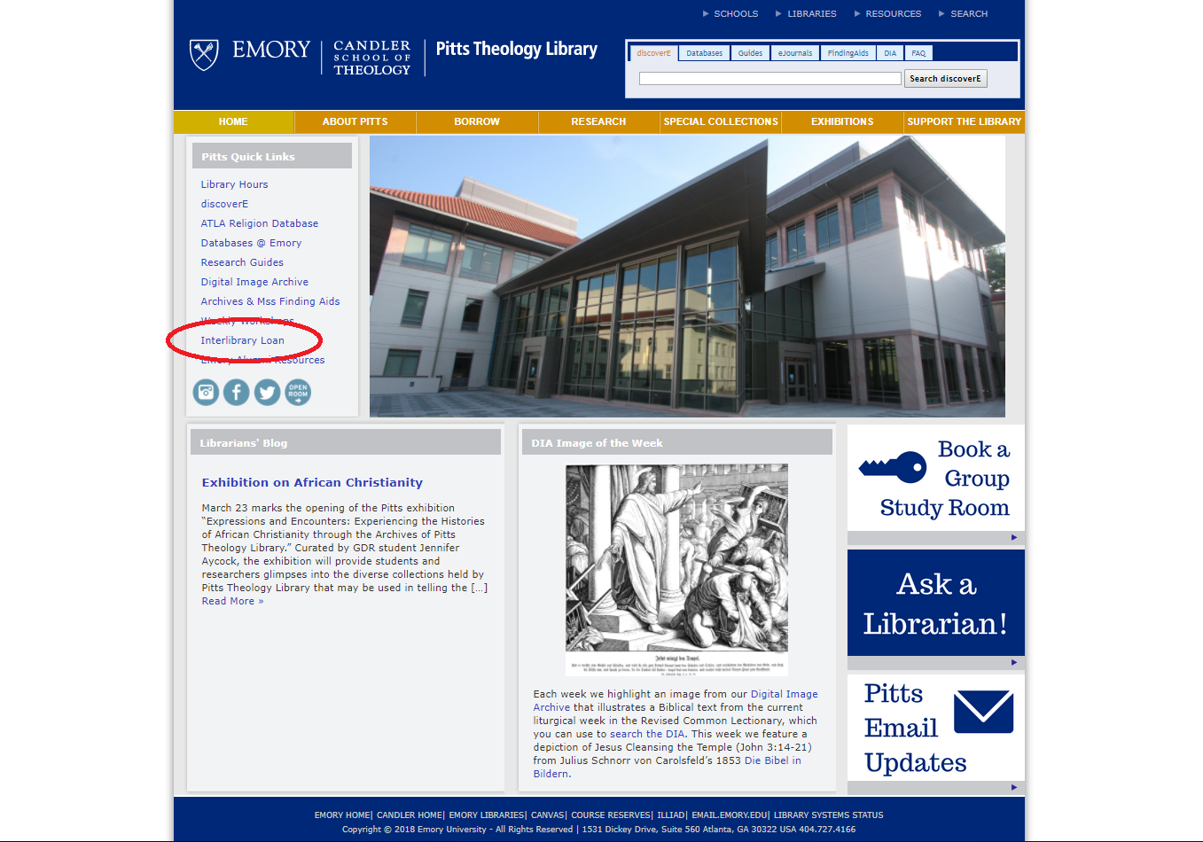

- Once you're at the ILLiad login screen, you're going to click the first option: Emory Students, Faculty, and Staff. Log in with your Emory credentials to continue to ILLiad.
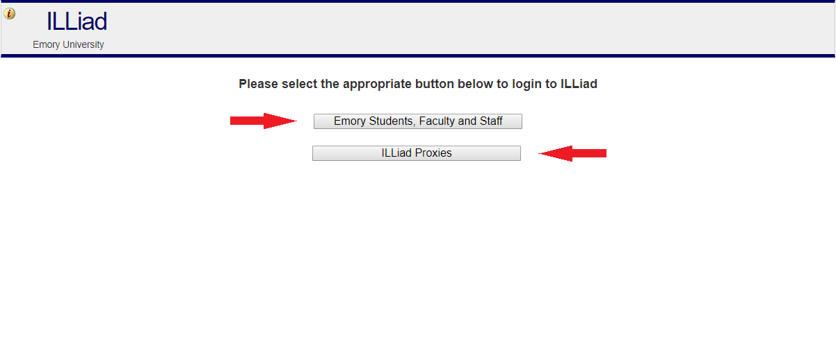
- From there, you're going to click on the link on the left side of the screen for Edit User Information.
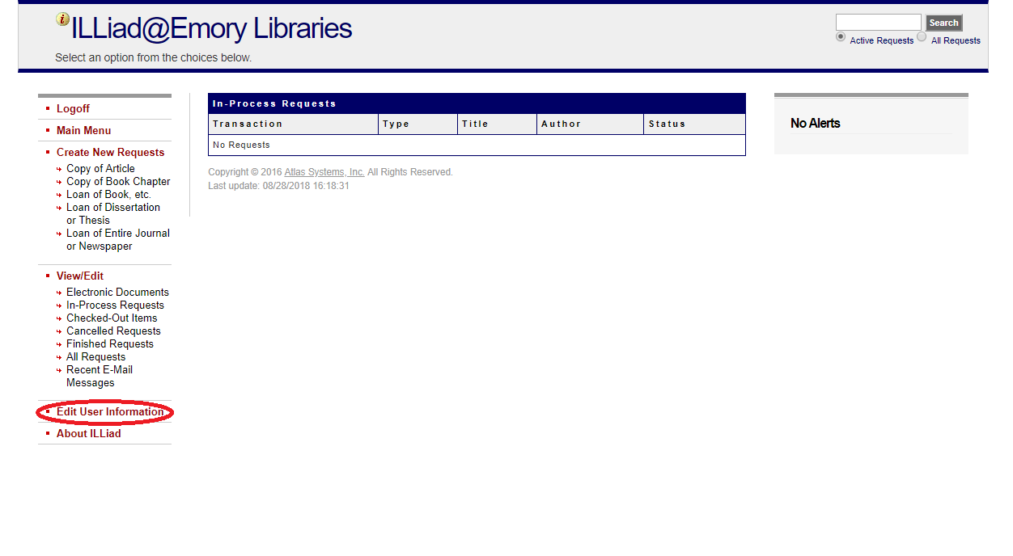

- On this screen, you should see the address, phone number, and email we have on file for you. You should be able to update all of this information, except for Home Library. If you have any trouble with this, please contact theill@emory.edu.
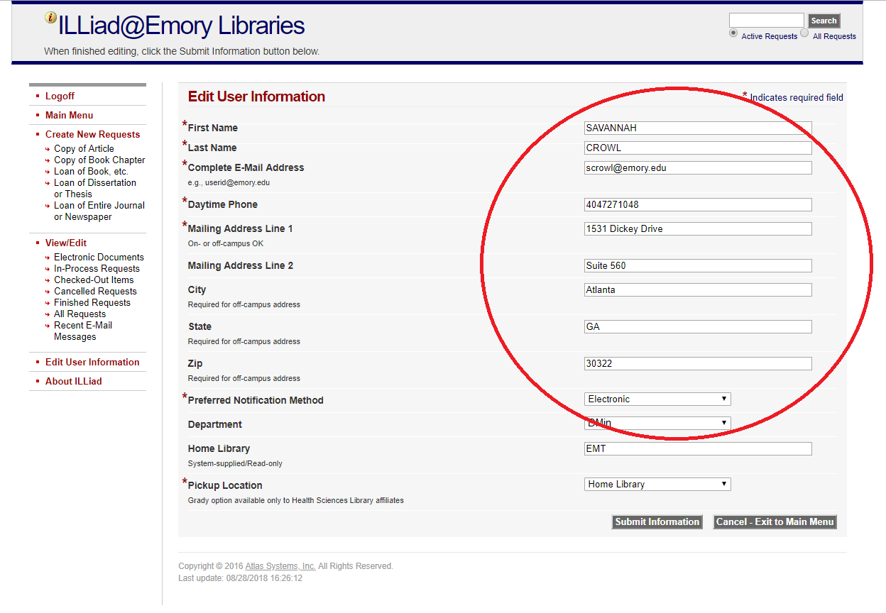

- Make sure to click Submit Information when you’ve made your edits!

